Holocene thinning and grounding-line retreat of the Darwin-Hatherton glacier system, Antarctica

Abstract

Outlet glaciers of the East Antarctic Ice Sheet thickened throughout the Transantarctic Mountains during Marine Isotope Stage 2 and fed a grounded ice sheet in the Ross Embayment. New exposure and radiocarbon ages of glacial deposits in four ice-free areas alongside Hatherton and Darwin glaciers record several hundred meters of late Pleistocene to early Holocene thickening relative to present, followed by thinning through the Holocene, as the grounding-line of the Ross Sea Ice Sheet retreated to the south. Darwin and Hatherton glaciers retreated from their high-stands later than glaciers farther south, only reaching their modern configuration ≤2.8 kyr BP. Converging flowlines from Byrd and Mulock Glaciers at the mouth of Darwin Glacier may have opposed rapid grounding-line retreat to the mouth of Darwin Glacier, while the grounding-line continued to retreat in the central Ross Embayment.

**Introduction**

*The last deglaciation in the Ross Embayment*

A thick ice sheet filled the Ross Embayment of Antarctica during Marine Isotope Stage 2 (MIS-2; XX-XX kyr BP), grounded near Coulman Island (73° S) (Anderson et al., 2013). Between 13 and 2 kyr BP, the grounding-line retreated >1,200 km to its current position along the Siple Coast. Conway et al. (1999) proposed that grounding-line recession followed the pattern of a swinging gate, with its hinge in the eastern Ross Sea. They based this hypothesis on three lines of evidence: (i) Radiocarbon ages of mollusk colonies, shells, and seals on beaches in Northern Victoria Land require the presence of open water by 8 cal. kyr BP. (ii) Radiocarbon ages of freeze-dried algae found in former ice-marginal ponds alongside Hatherton Glacier, a tributary of Darwin Glacier, suggest that the glacier system reached its present configuration before 6.8 kyr BP (Bockheim et al., 1989). (iii) An ice flow model of Roosevelt Island best fits the observed Raymond bump (Raymond, 1983) in radar layers if divide flow initiated ~3.2 kyr BP.

This chronology has been repeatedly modified with multiple new lines of evidence. Martín et al. (2006) used a thermomechanically-coupled transient model to refine the estimate of the initiation of divide flow at Roosevelt Island. They found that a high power (n=4) rheology is required to match the shape of the Raymond bump, and that divide flow likely initiated 3.0 +1.2/-0.7 kyr BP. Todd et al. (2010) mapped and dated deposits alongside Reedy Glacier, and showed that thinning initiated ~13 kyr BP and had largely ceased by 1 kyr BP. Exposure ages from deposits alongside Shackleton and Beardmore Glaciers show that these glaciers had reached modern elevations by 7.4 kyr BP, and the chronology at Scott Glacier shows that the Ross Ice Shelf grounding-line reached its present position between Reedy and Scott Glaciers around 3 kyr BP (Spector et al., 2017). This suggests that the 1100 km-long section of the TAMs front deglaciated almost contemporaneously in the early Holocene, followed by slow recession into the late Holocene.

Anderson et al. (2004) used a numerical model of the Darwin-Hatherton glacier system to show that fluctuations of Hatherton Glacier may have lagged changes at the mouth of Darwin Glacier by as much as 1100 years. This uncertainty causes considerable overlap with ages from Bockheim et al. (XX) with the date of deglaciation in Northern Victoria Land at 7.8 kyr BP. However, Anderson et al. (2004) did not have knowledge of the bed topography or basal conditions at Hatherton or Darwin Glaciers; analysis like this should therefore be revised using new data from aerial and ground geophysics surveys (Gillespie et al, 2017) in order to evaluate the best model of glacier flow.

In this paper, we revisit the chronology of the Darwin and Hatherton glaciers since the penultimate glaciation with new surface exposure ages of glacial erratics and of bedrock, as well as radiocarbon ages of freeze-dried algae. Advances in radiocarbon dating since the 1980s and the advent of surface-exposure dating allow us to examine the history of this glacier system with higher spatial resolution and temporal data constraints than available for previous interpretations (Bockheim et al., 1989). The data presented here do not contain enough temporal overlap between the Darwin Glacier and Hatherton Glacier chronologies to discuss the response time of Hatherton Glacier to changes at the mouth of Darwin Glacier. So, we use a 1.5-dimensional finite-volume flowband model to determine what can be deduced about Last Glacial Maximum (LGM) and deglaciation conditions at the mouth of Darwin Glacier from the more complete chronologies we have constructed from alongside Hatherton Glacier.

*Physiographic setting of Darwin and Hatherton Glaciers*

Darwin Glacier and its major tributary Hatherton Glacier are outlet glaciers of the East Antarctic Ice Sheet that flow through the TAM into the modern Ross Ice Shelf. In contrast to the neighboring fast-flowing Byrd and Mulock glaciers, ice-flow velocities for the Darwin-Hatherton glacier system do not exceed 110 m yr-1, and everywhere the velocity of Hatherton Glacier is <12 m yr-1 (Rignot et al., 2011; Gillespie et al., 2017). The glaciers have a very small catchment within the East Antarctic Ice Sheet, due to both high bedrock topography preventing flow into their canyons and to the proximity of the much larger Byrd and Mulock glaciers, whose catchments effectively behead the Darwin-Hatherton catchment (Swithinbank, 1988; Gillespie et al., 2017)

…

(This section will contain a short summary of the glaciologic and geographic setting described in Gillespie et al. (2017), the boundary-layer meteorology of Noonan et al. (2015), accumulation rates (RACMO, Bockheim et al., Gillespie, Arthern et al…). Perhaps we should also a short discussion of bedrock geology, if this goes somewhere like GSA Bulletin [Cottle and Cooper (2006), Haskell et al. (1965), Simpson and Cooper (2002), Felder and Faure (1991), and Woolfe (1993)].) [Sounds good!]

*The Darwin-Hatherton Glacier System during MIS-2 and the Holocene*

Outlet glaciers throughout the TAM thickened first at their mouths during MIS-2 in response to thickened, grounded ice in the Ross Sea, and later at their heads due to increased accumulation after the LGM (Todd et al., 2010). Lateral moraines of MIS-2 age have been used to interpret ice thicknesses of both the grounded Ross Ice Sheet and EAIS outlet glaciers (Bockheim et al., 1989; Denton et al., 1989; Todd et al., 2010; Spector et al., 2017).

Bockheim et al. (1989) mapped lateral moraines and drift sheets in ice-free valleys alongside Hatherton Glacier, and dated these deposits based on weathering, soil characteristics, and a small number of radiocarbon ages of freeze-dried algae. These algae grew in glacier-dammed ponds, and they died as the glacier thinned and drained the ponds after the local LGM. These ages thus provide a good proxy for the glacier margin position through time, subject to the uncertainties of the pond size (any ref here?). Bockheim et al. (1989) tentatively attributed the Britannia II drift sheet to the LGM, and interpreted the Britannia I drift several hundred meters inboard as a Holocene readvance or stillstand. They named the unweathered drift sheet immediately adjacent to the glacier margin the Hatherton drift. Two much older drifts they termed the Danum (MIS-6) and Isca (much older, but undated).

The Britannia II drift lies 100 m above the current glacier margin at the head of Hatherton Glacier, and 450 m above the current margin in the middle of the glacier profile. Bockheim et al. (1989) extrapolated this to infer up to 1100 m of thickening at the confluence of Darwin Glacier with the Ross Ice Sheet during MIS-2, although they found no deposits there. Anderson et al.’s (2004) numerical model yielded a more modest 800 m of thickening. Forthcoming cosmogenic *in situ* 14C measurements from bedrock at the mouth of Darwin Glacier will constrain the LGM ice thickness at the mouth of Darwin Glacier.

Storey et al. (2010) revisited the Lake Wellman area, where Bockheim et al. (1989) found 450 m of LGM thickening, and used surface exposure dating to determine the age of the Britannia and Hatherton drift limits. Their ages for the Britannia drift range from 22 to 182 kyr BP, but they interpreted a cluster of five ages with a mean of 35 kyr BP to represent the age of the drift sheet. They correlated the Hatherton drift, only 70-100 m above glacier level, to minor LGM thickening or a Holocene deglaciation event. These interpretations would indicate either that Hatherton Glacier did not respond to thickening of ice in the Ross Sea during MIS-2, or that ice in the Ross Sea did not ground and thicken during MIS-2. These results are in conflict with the vast majority of glacial geological data (e.g., Baroni and Hall, 2004; Conway et al., 1999; Denton et al., 1989; Stone et al., 2003; Todd et al., 2010; Bromley et al., 2010), marine geologic data (e.g., Shipp et al., 1999; Domack et al., 1999), geophysical data (e.g., Price et al., 2007; Conway et al., 1999), and model results (e.g., Anderson et al., 2004; Waddington et al., 2005; Martín et al., 2006; Pollard and Deconto, 2009; Whitehouse et al., 2011).

Joy et al. (2014) revisited the upper Hatherton Glacier in order to date the deposits in Dubris and Bibra Valleys using surface exposure dating. They showed the Britannia II drift is in fact of MIS-6 age, and the Britannia I drift is of Holocene in age. Using Storey et al.’s (2010) conclusion that lower Hatherton Glacier did not thicken at the LGM, they suggested that the ice thickness of the upper Hatherton Glacier is predominantly controlled by accumulation-driven fluctuations of the EAIS, and that the EAIS ice was thinner during the LGM. However, the LGM in Antarctica is known to be later than the global LGM by thousands of years (Stone et al., 2003; Hall et al., 2015), and the Holocene age of the Britannia I drift is in agreement with ages from glaciers throughout the TAM (Todd et al., 2010; Spector et al., unpublished).

The deglaciation chronology of the Darwin-Hatherton glacier system has been used as one of three key constraints in the swinging gate model of Ross Sea grounding-line retreat (Conway et al., 1999), but this chronology was based on a handful of bulk radiocarbon ages, which likely resulted in an averaging effect on the ages. Furthermore, these samples were collected alongside Hatherton Glacier, which is >50 km from the modern grounding-line, and is influenced both by a lagged response to grounding-line position and by changes in surface mass balance. It is therefore necessary to gain a more regional view of the deglaciation history of these glaciers in order to accurately assess the timing both of the establishment of the modern grounding-line position and of steady flow at Hatherton Glacier.

*Description of Deposits*

We refer the reader to the comprehensive paper by Bockheim et al. (1989) for a more complete description of the deposits. Here we only summarize the general characteristics of each deposit, noting observations pertinent to our chronology that may be missing from the description of Bockheim et al.

**…**

**Methods**

*Exposure dating of glacial erratics and bedrock*

*Radiocarbon dating of sub-fossil algae*

*Numerical model*

*[Do you want me to help with writing some of this section? Or at least I can hack in heavily after you get something down, though you may have text around from class projects that will be plenty of description—also feel free to use anything from the proposal, do you have a copy of that?]*

**Results: Exposure dating**

Hatherton Glacier

*Britannia II*

Our chronology supports the conclusion of Joy et al. (2014) that the Britannia II deposit is a product of the penultimate glaciation. While Joy et al. give a mean 10Be age of 126 ± 3.2 kyr BP (n = 5), we find an 26Al age of 141 ± 3 kyr (n = 9; reduced Χ2 = 1.35). Recalculation of Joy et al.’s ages using an updated estimate of the 10Be production rate yields an age of 138 ± 4 kyr, in close agreement with our 26Al age. Our initial attempt to date the Britannia II limit using 10Be resulted in a widely spread dataset (FIGURE), which yielded an age of ~133 kyr BP (n = 9; reduced Χ2 = 57.9). This underestimation of 10Be ages is consistent throughout most of the samples that we dated using both 10Be and 26Al. We attribute it to a persistent analytical bias at the CAMS accelerator during analysis.

*Britannia I*

The Britannia I drift limits alongside Hatherton Glacier reveal a stable maximum extent between 7.5 and 8.5 kyr BP (Figure X). Variations in the age of the limit of deposition are to be expected, as many variables can control the local scale dynamics of the glacier margin, including local wind patterns, air temperatures, and bed topography (need citation here; this is really just a thought). Therefore, the 7.5 kyr BP age of the limit on Updog Mountain should not be interpreted as differing significantly from the 8 kyr or 8.2 kyr ages from the nearby Danum Platform and Dubris Valley. The probability peak at Magnis Valley is slightly older than the upper valleys, at ~8.6 kyr BP; however, as these ages are reported with 1-sigma errors, this is likely not statistically significant.

*Lake Wellman*

While we were not able to obtain reliable exposure ages from the Britannia deposits in the Lake Wellman area, radiocarbon ages of algae from former Lakes Wellman show a strong dependence of age on elevation, with a stable maximum position from 13 kyr BP until ~8 kyr BP, followed by steady thinning to modern elevations by the late Holocene. Bockheim et al. (1989) and Storey et al. (2010) were not able to differentiate between the Britannia I and II drifts at Lake Wellman, but King et al. (2017) mapped the Britannia II limit slightly outboard of the Britannia I limit. There were no algae present in the Britannia II drift, and we did not sample it for surface exposure dating.

Darwin Glacier

We visited the Brown Hills and Diamond Hill, adjacent to Darwin Glacier and the Ross Ice Shelf in December, 2014. Previous attempts to date the deposits at the mouth of Darwin Glacier proved inconclusive (Bockheim et al., 1989; Joy, 2013).

*Brown Hills*

The Brown Hills lie adjacent to Diamond Glacier—a distributary lobe of Darwin Glacier—and to the Ross Ice Shelf. During glacial periods, Diamond Glacier would very likely have crossed the Brown Hills and connected with the Ross Ice Sheet. However, because the ice-free topography here is several hundred meters above sea level, the ice would have been thin, fast flowing (Kavanaugh et al. 2009), and very soon cut off from the thick ice sheet during retreat. Therefore, we would expect ages from recessional deposits in the Brown Hills to predate the chronologies of Hatherton or Darwin Glaciers.

We dated five erratics from the Brown Hills, including the Diamond Glacier side of Diamond Hill. The highest of these samples was a fresh-looking granite cobble taken from a weathered deposit high on Diamond Hill (877 m asl). While it was unweathered compared with the pre-LGM deposit it was perched on, it yielded a 10Be age of 205 ± 5 kyr, and thus it is either (i) recently exhumed from the older deposit, or (ii) a deposit of the last glaciation, with a high level of inherited 10Be. A single date from this deposit is not a good age constraint; however, based on the weathering characteristics of the pre-LGM deposit on which the rock sits, we conclude that thick ice covered much of Diamond Hill at least once in the Pleistocene. We did not find deposits of the last glaciation high on Diamond Hill.

The exposure ages of the erratics from the Brown Hills also provide only circumstantial constraints on the last glacial advance. One rock was heavily pitted and stained and yielded a 10Be age of 196 ± 5 kyr. Of the remaining three, only one gave a Holocene exposure age (7.1 ± 0.2 kyr; 390 m asl). The other two dated to 33.7 ± 0.9 kyr (385 m asl) and 17.8 ± 0.4 kyr (450 m asl). This dataset shows no dependence on elevation or distance from the current glacier margin, likely because of inherited 10Be or local scale fluctuations not controlled by regional ice dynamics or climate. However, this does show that ice had largely retreated from the Brown Hills, and therefore had disconnected from the Ross Ice Shelf/Sheet by ~7 kyr BP. The implications of this result for the larger glacier system are unclear; however, future analyses of *in-situ* cosmogenic 14C in bedrock from the Brown Hills may provide further insight.

*Diamond Hill erratics*

The only relatively fresh, unweathered erratics on Diamond Hill were perched on glacially sculpted bedrock domes overlooking Darwin Glacier, ~10 km upglacier from the modern grounding-line (FIGURE: Field photographs). We dated 8 of these erratics, spanning 135 m of elevation above the current glacier margin, and we collected bedrock samples at each site where we collected erratics. There was no clear limit of deposition. These 8 erratics give 10Be ages spanning the latter half of the Holocene, from 5.2 ± 0.2 kyr BP 135 m above the current glacier margin, to 0.3 ± 0.03 kyr BP at the current glacier margin. The rate of thinning appears to have been relatively constant between 5.2 and 3.1 kyr BP, after which it slowed down.

Anderson et al. (2004) showed that the LGM ice surface was higher than 135 m above the current glacier margin, and we note that the lack of deposits does not necessarily imply ice-free conditions at the LGM. The ice above this could have been cold-based and debris-free, and thus did not deposit as it retreated from the side of Diamond Hill. The steep terrain and shear size of Diamond Hill prevented us from covering every piece of ground; however, we did climb to the top of Diamond Hill on the northern (ice-shelf proximal) side, and descended on the western (Brown Hills proximal) side, and we found no indication of LGM deposits.

*Diamond Hill bedrock*

We analyzed cosmogenic *in situ* 14C in an elevation transect of granitic bedrock from Diamond Hill in order to constrain the ice thickness at the LGM. Because any rock exposed *prior to* the LGM will contain some amount of inherited 14C, an apparent 14C exposure age acts as an upper bound on the timing of exposure since the LGM. Within the range of erosion rates typically found in Antarctic bedrock (<1 micron/yr), 14C concentrations reach secular equilibrium in <30 kyr (Balco et al., 2016). Because of the short half-life of 14C, a few thousand years of ice cover during the LGM will create a detectable signal of burial, while rock that was not covered with ice in the last 30 kyr will remain at its equilibrium concentration. Therefore the LGM ice surface elevation will be bracketed above by the lowest sample that is saturated with respect to 14C and below by the highest unsaturated sample.

The apparent *in situ* 14C exposure ages do not show a simple relationship between age and elevation. On the flank of Diamond Hill overlooking Darwin Glacier, our highest bedrock sample (14-HAT-026-DH; 472 masl) gives an apparent exposure age of 6.7 ± 0.7 kyr BP, 200 m above the modern glacier margin. Bedrock sampled <2 m above the current ice margin (14-HAT-033-DH; 280 masl), and adjacent to the 300 year old erratic gives an apparent 14C exposure age of 500 ± 200 years BP. These ages confirm and extend the thinning chronology given by the 10Be exposure ages of the nearby erratics. Thus, it is apparent that Darwin Glacier thinned by 200 m between 6.7 ± 0.7 kyr BP and 500 ± 200 years BP. 500 m above the glacier margin on the ice shelf side of Diamond Hill, the bedrock is at or near the saturation level for 14C (14-HAT-006-DH; 593 masl). This sample was either not covered by ice during the last glaciation, or covered for only a brief period (< 1kyr), and thus provides an upper bound on the LGM ice surface elevation near the modern grounding-line.

Above Diamond Glacier, *in situ* 14C concentrations are well below saturation. On bedrock ridges at 813 masl (14-HAT-035-DH) and 1135 masl (14-HAT-039-DH), the apparent bedrock exposure ages are 4.3 ± 0.4 kyr at 5.3 ± 0.5 kyr, respectively. Diamond Glacier terminates in a bedrock saddle between Diamond Hill and the Brown Hills below these samples at ~350 masl. While Darwin Glacier had thinned to within 135 m of its modern thickness by ~5.1 kyr BP, Diamond Glacier was still at least 785 m thicker than present at this time.

**Results: Ice flow model**

We evaluated two end-member model frameworks of deglaciation ice-thickness change at the mouth of Darwin Glacier. In the first case, we forced the ice thickness at the mouth with the output of a 3D ice sheet model, run at 5 km resolution in the vicinity of Darwin and Hatherton glaciers. The model is tuned to fit the previously available geologic data from the last deglaciation (Pollard and Deconto, 2016), and it predicts rapid grounding-line retreat between Minna Bluff and the mouth of Darwin Glacier from 10.2 to 9.0 kyr BP, accompanied by a drastic drop in the ice surface at Diamond Hill between 9.4 and 9.0 kyr BP (Figure 5). We ran a small ensemble of seven model runs, using this ice-thickness history as a boundary condition at Darwin Glacier. Figure 6a shows that this deglaciation scenario does not match our data from the mouth of Darwin Glacier, nor does it agree with any of the chronologies we present for Hatherton Glacier.

In the second case, we constructed a deglaciation scenario that is defined by our exposure ages at Diamond Hill, and extrapolated linearly backward in time prior to 5.1 kyr BP (Figure 6b). When we forced our 1.5-D flowband model with this slow and steady deglaciation history near the modern grounding-line, we are able to fit our glacial geologic data from Hatherton Glacier reasonably well. Thus, we prefer a slow and steady deglaciation through the Holocene, driven by grounding-line retreat that was much slower than that experienced by Beardmore Glacier and by other sites in the southern Ross Embayment.

… Much more to come in this section

**Discussion**

*Timing of grounding-line arrival*

Although our dataset from Diamond Hill is limited to elevations within 135 m of the preset glacier surface, we can conclude that the profiles of Darwin and Hatherton glaciers continued to respond to changes in grounding-line position until ~3 kyr BP. The bedrock at the margin of Darwin Glacier is glacially polished and striated, indicating that the glacier was wet-based and erosive at the LGM. Separate model results indicate that it is likely wet-based even today (Riger-Kusk, 2011), and we thus expect that it was wet-based throughout the Holocene. Therefore, changes at the grounding-line likely propagate upglacier rapidly, and the lag time at the point adjacent to Diamond Hill is short (a few tens of years). Darwin Glacier did not achieve steady flow until ≤ 3 kyr BP, which means that the age of >6.8 kyr BP that Conway et al. (1999) used to constrain the timing of grounding-line retreat greatly overestimates the timing of the modern grounding-line stabilizing at the near-modern position at the mouth of Darwin Glacier.

The steady thinning of Hatherton Glacier through the Holocene also supports a later arrival of the grounding-line relative to glaciers to the north and south (Hall et al., 2015; Jones et al., 2016; Spector et al., 2017). If there was an episode of very large and rapid thinning at the mouth of Darwin Glacier corresponding to rapid encroachment of the grounding-line, this would likely be recorded in the chronologies from Hatherton Glacier. These chronologies give no indication of a dramatic and rapid pulse of grounding-line retreat prior to the oldest erratic at Diamond Hill (5.1 kyr BP). The youngest erratic at Dubris and Bibra Valleys at the head of Hatherton Glacier is ~80 m above and 1.2 km away from the current glacier margin, and dates to 3.3 kyr BP. If 80 m of thinning was accomplished at the same average rate of thinning (~0.04 m/yr), the glacier would have reached its modern position at 1.3 kyr BP, which is consistent with the ages of the youngest erratic from Lake Wellman. Even accounting for a 1.1 kyr response time for Hatherton Glacier (Anderson et al., 2004), this means that the grounding-line was still far from its modern configuration ≤ 4.4 kyr BP.

We are not able to discern either the absolute rate of grounding-line retreat or the distance to the grounding-line at any given time during deglaciation. However, by correlating our chronologies to other datasets within the Ross Sea sector, we can make a first-order estimate of the sensitivity of Hatherton Glacier to grounding-line position. Marine sedimentary records show that the grounding-line retreated past Ross Island >8.6 kyr BP, ~400 km from the current grounding-line of Darwin Glacier (McKay et al., 2016). Hatherton Glacier began to retreat from its last high-stand 8 – 9 kyr BP, suggesting that at this distance the influence of the downstream boundary condition overcame the influence of increased Holocene accumulation. Because marine ice sheet style grounding-line retreat is likely much faster than corresponding changes in ice thickness far upglacier, it is difficult to say whether Hatherton Glacier began to respond because the grounding-line came within some critical threshold distance, or if the kinematic wave of thinning took until this time to reach the glacier. Alley and Whillans (1984) investigated the effect of sea-level rise on the East Antarctic Ice Sheet, and found that it took ~3 kyr for ice at the divide to thin by just a few cm per year, equivalent to the rates of thinning we find at Darwin and Hatherton Glaciers. This modeling experiment used a step change in sea level, which is not realistic; however, it is perhaps analogous to the threshold behavior of grounding-line retreat exhibited by marine-terminating outlets.

It remains to be shown that the 135 m of thinning we document at the mouth of Darwin Glacier is due to the approach of the grounding-line, and not a minor adjustment after the grounding-line arrived. The chronologies along Hatherton Glacier all record smooth and steady thinning through the Holocene (Figure X), which supports but does not prove smooth and steady retreat of the grounding-line. The effect of a cold, stiff bed would be to delay the propagation upglacier of changes at the grounding-line, which could thus smooth out the signal of rapid thinning at the mouth of Darwin Glacier. To allay this suspicion, we examined the response of Hatherton Glacier to rapid thinning at the mouth of Darwin Glacier, using our 1.5-D flowband model.

*Large-scale pattern of grounding-line retreat in the Ross Sea*

The grounding-line of the WAIS in the Ross Embayment retreated southward from its maximum position ~12.8 kyr BP (Hall et al., 2015). The rate and pattern of retreat were likely controlled by the bathymetry of the bed; more rapid retreat took place in deep troughs, while ice rises developed on the banks between them (Dowdeswell et al., 2008). Such complex behavior cannot be deduced from our data; however, by comparing the timing of grounding-line arrival at various points along the TAM front, we can begin to discern what the pattern of grounding-line retreat may have been in the western Ross Sea.

Sub-shelf sedimentation at the Coulman High, near Ross Island, began >8.6 kyr BP (McKay et al., 2016). This is approximately contemporaneous with the establishment of the modern grounding-line at Beardmore Glacier (Spector et al, 2017). Darwin and Hatherton Glaciers lie roughly halfway between these two points, yet the timing of grounding-line arrival is much younger. The modern grounding-line at Reedy Glacier/Mercer Ice Stream was established ~2 kyr BP.

This pattern of grounding-line retreat requires that a large region of ice in front of Byrd, Darwin, Mulock, and Skelton glaciers remained grounded long after the grounding-line of the central Ross Embayment had retreated further south. It remains an open question how far along the TAM front this grounded ice persisted, and if it comprised a single, grounded ice mass or local piedmont lobes.

The delayed deglaciation of the Darwin and Hatherton Glaciers is likely due to the convergence of Byrd and Mulock Glaciers directly in front of Darwin Glacier. Numerical investigations of grounding-line dynamics show that convergent flow can counteract the acceleration of dynamic thinning as the grounding-line retreats down a reverse bed slope (Gudmundsen, 2013). The lateral drag of the Byrd-Darwin-Mulock flowband past Minna Bluff and any transient ice rises on the intertrough ridges would also have served to buttress the upstream ice (Thomas, 1979). Together, these two effects could have created a sheltered embayment that was able to resist grounding-line retreat longer than glaciers farther to the south.

**Conclusions**

Remind reader what new data were collected and modeling done.

* Glacial deposits on the walls and floors of ice-free valley alongside Hatherton Glacier record up to 450 m of thickening relative to present at Lake Wellman, 350 at Magnis Valley, and 300 m at Dubris Valley. The glacier margin extending several kilometers into each valley during its maximum, and held a steady position for several thousand years before receding slowly and steadily through the Holocene. It did not reach its present thickness until ≤2.8 kyr BP.
* Maximum bedrock 14C exposure ages constrain the LGM ice surface near the modern grounding-line of Darwin Glacier to >190m but likely <500 m above the modern glacier. On the other side of Diamond Hill, the Diamond Glacier thickened by almost 800 m, and remained thick into the late Holocene.
* Flowband model results show that the high-resolution chronologies we have established for Hatherton Glacier are not consistent with a rapid deglaciation event 9 kyr BP, as predicted by the 3D ice sheet model. Instead, our data are most consistent with slow and steady thinning at the mouth of Darwin Glacier accompanied by slow and steady grounding-line retreat between ~10 kyr BP and ~2 kyr BP.
* How this could happen…

References

etcFigures

Figure 1: Location of Darwin and Hatherton Glaciers. Our four sample collection areas are marked: Diamond Hill (DH), Lake Wellman (LW), Magnis Valley (MV), and Dubris Valley (DV)

Figure 2: Probably some photographs of the deposits at each location.

Figure 3: Simplified maps of sample locations.

Figure 4: All algae radiocarbon, bedrock 14C, and erratic exposure ages from Darwin and Hatherton glaciers, including data from King et al. (unpublished). Left column includes only ages <15 kyr, while right-hand column includes exposure ages of all erratics, including those with significant inherited nuclides. This is a place-holder figure. TH will make a much better one soon.

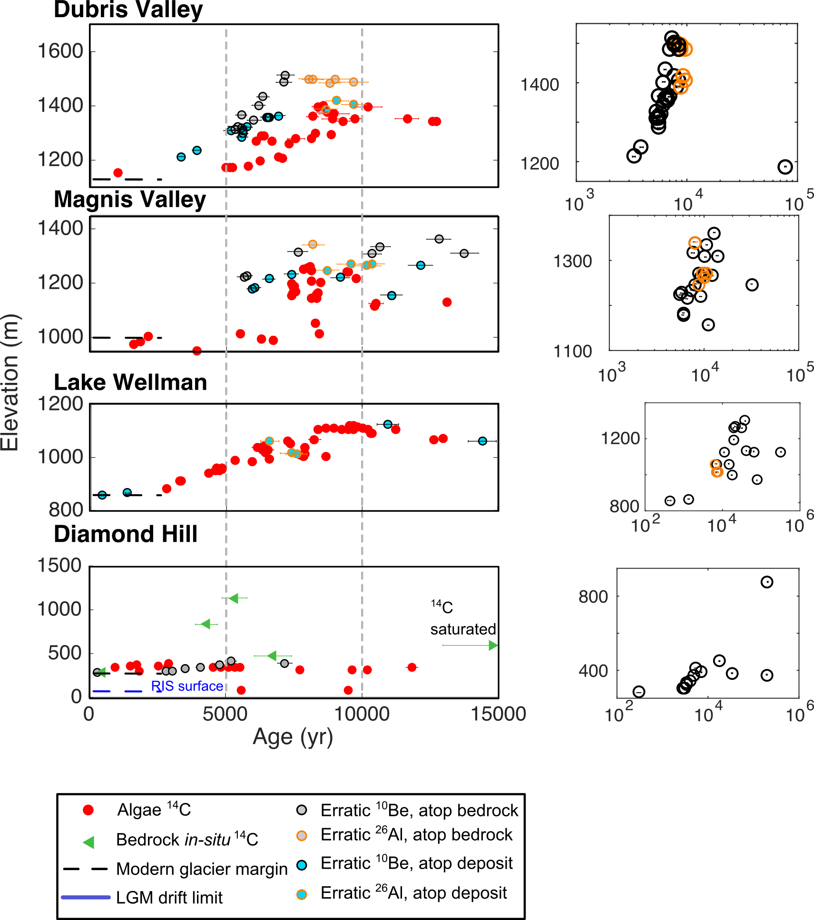

Figure 5: Output of a 3D ice sheet model run at 5km for the domain shown, nested within a 20 km resolution whole ice sheet model. The model predicts 400 km of grounding-line retreat to the mouth of Darwin Glacier in ~400 years.

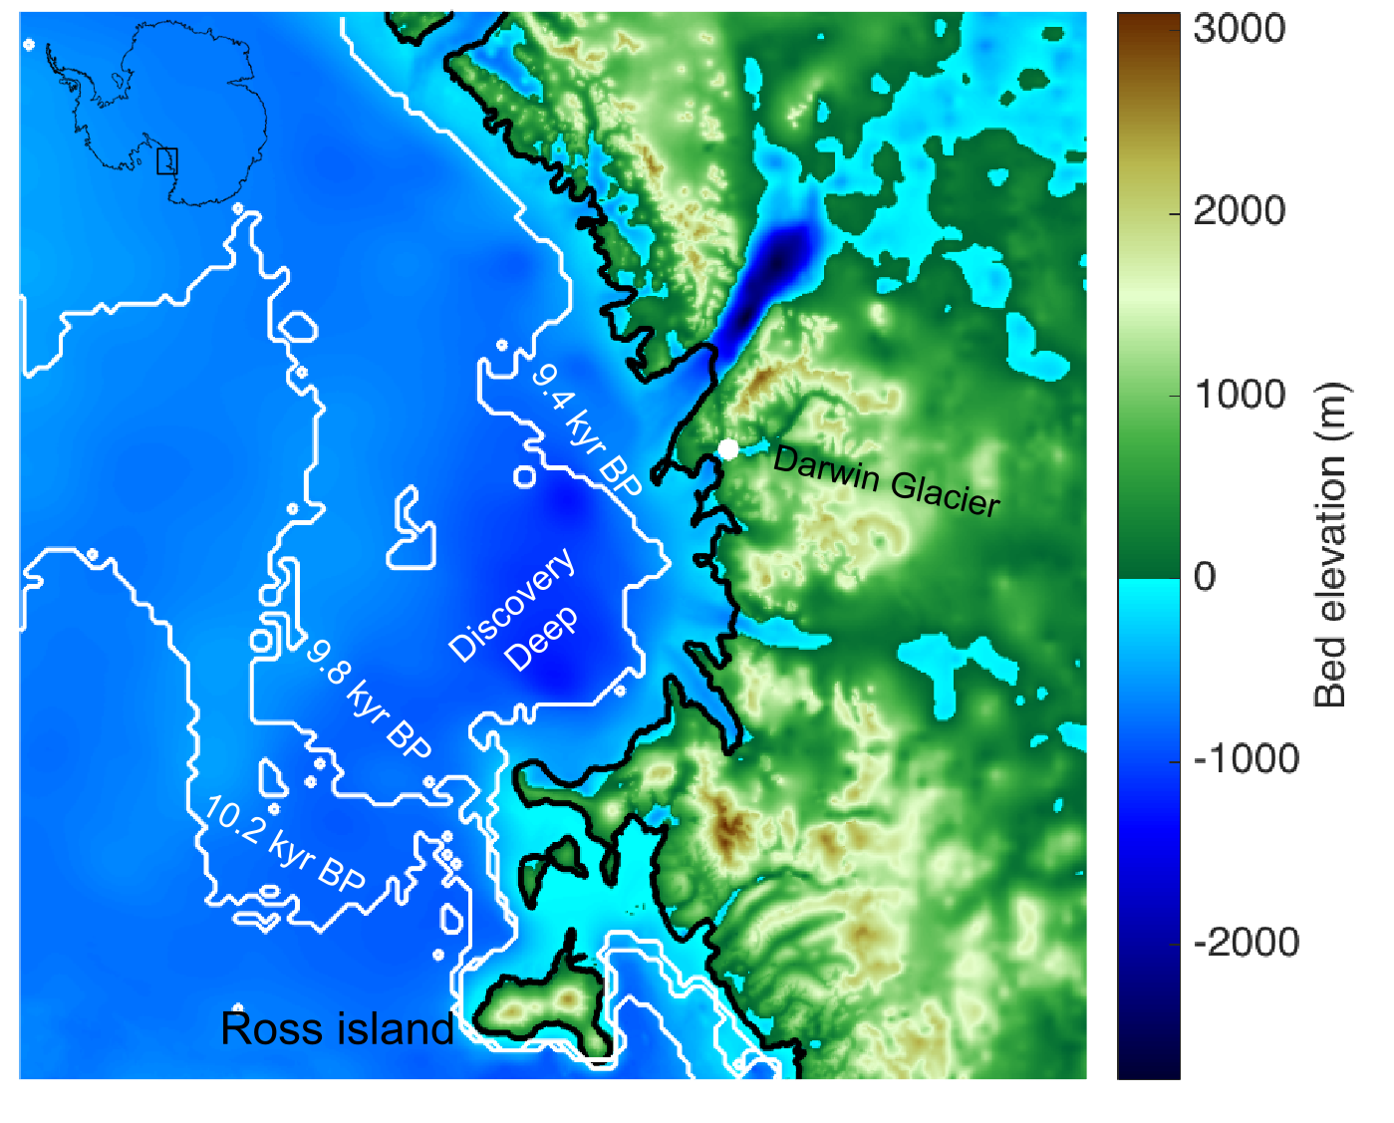

Figure 6: Flowband model output. I will add these tomorrow when I don’t want to murder Inkscape anymore.

[ Let me know if I can help! ]

Did we settle on this for final, or need any more runs? Come on, more runs, more runs … just kidding, at any point we cut off and claim victory! Though should be up front about assumptions, I think we were fairly complete in checking sensitivities and can do a few more to feel good about that and backup a sentence or two about geometry and boundary conditions we must prescribe.

Notes, Questions, things to explore:

1. Did the Britannia II deposit continue all the way back under Britannia I, or does it stop where Britannia I starts up? This is important to be able to determine if Hatherton thinned beyond Britannia I limit between MIS 6 and MIS 2
2. Bockheim pg 247: ”The most conservative course is to interpret these C-14 dates simply as minimum values for ice recession from the sample sites.” I just realized that the receding lobe could leave behind ice-cored stuff that would not require a glacier dam. Therefore, certain of Brenda and Courtney’s anomalously old ages could be from ponds trapped in ice-cored, hummocky terrain that today appears to require an ice dam.
3. It looks like retreat from Magnis Valley initiated ~1 kyr before retreat from Dubris-Bibra Valleys and Danum Platform. Does this mean that it was controlled by the grounding-line? Bockheim et al claimed their 6.8 kyr BP date was the time at which the longitudinal profile became steady, but now it is looking more like that is around 3 kyr BP.
4. In order to figure out whether the last 135 m of thinning of Darwin Glacier was due to grounding-line arrival or just some small adjustment after the arrival, I will constrain the flowband model with the Hatherton Glacier chronologies and explore different thinning histories at Diamond Hill.
5. In order to determine whether Hatherton and Darwin Glaciers would respond to changes at the LGM grounding-line, we modeled the glaciers to the LGM grounding-line using a SIA steady-state 1.5D flowband model. While we do not expect the SIA model to faithfully recreate ice dynamics near the grounding-line due to the increasing influence of longitudinal stresses that are not accounted for in the SIA, this likely has very little affect on the ice surface profile very far upglacier. We then forced the grounding-line to retreat to within 400 km of its modern position, and allowed the profile to evolve. [something to explore here?]